Hazardous Materials

1. This fluid is flammable and powers most combustion engines. What is it?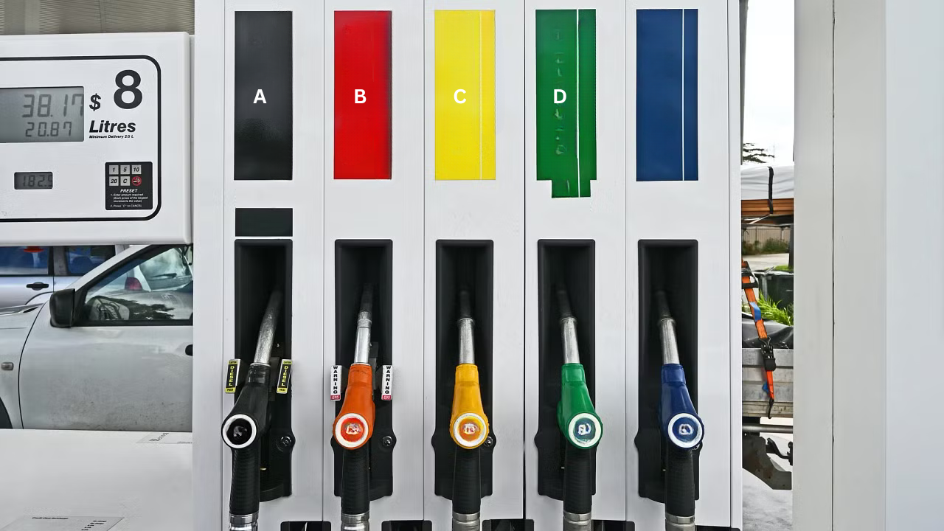

A. Antifreeze

B. Engine oil

C. Diesel exhaust fluid

D. Gasoline (Petrol)

**Correct Answer: D. Gasoline (Petrol)**

1. Which battery component is considered hazardous due to its acidic content and lead plates?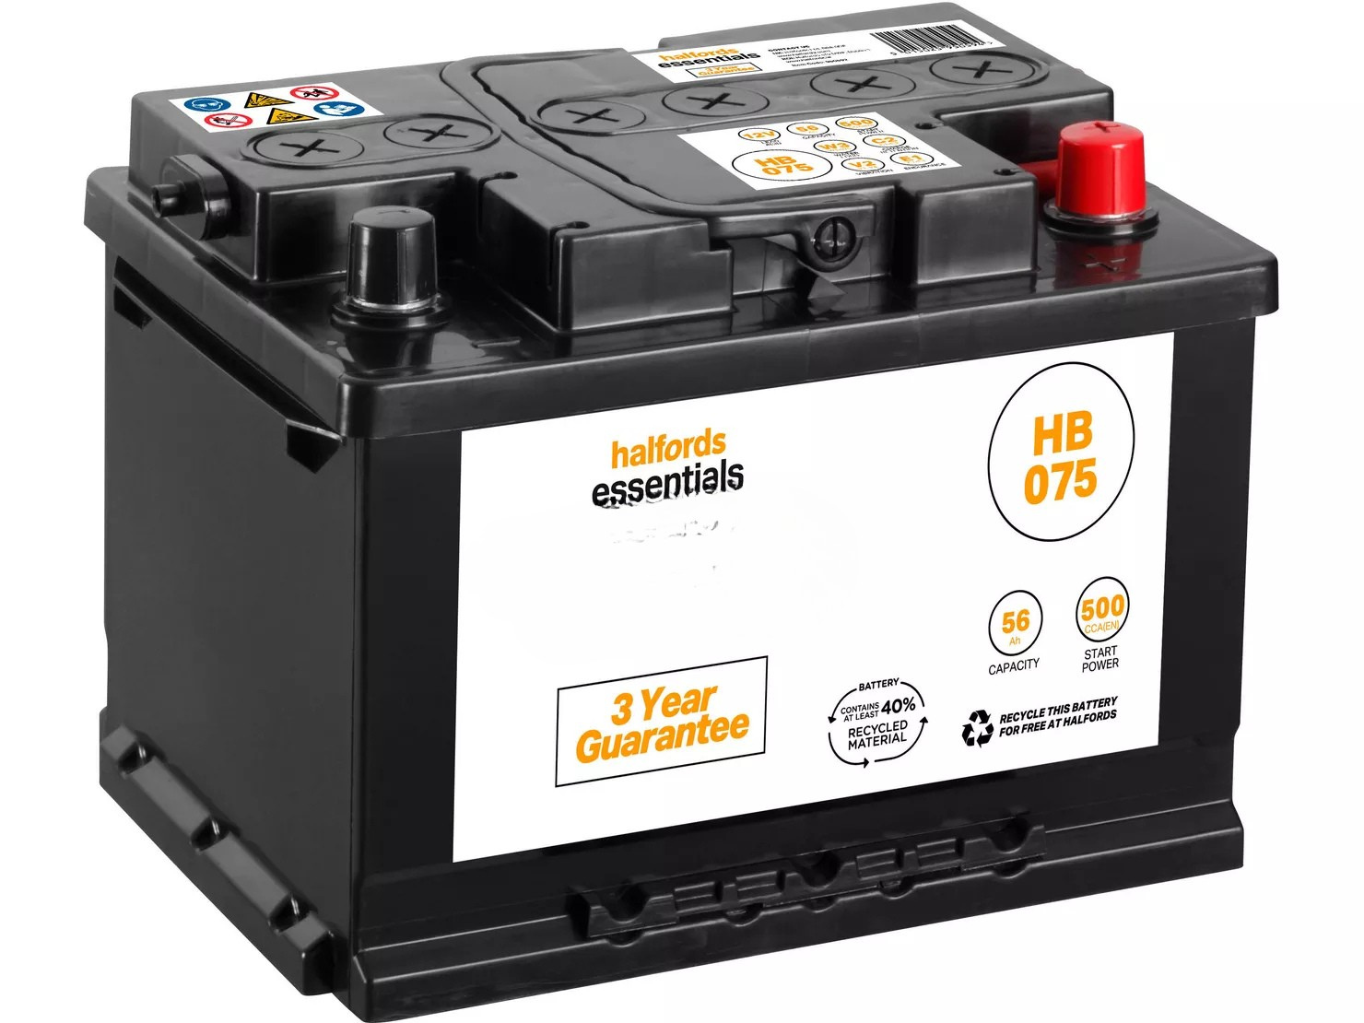

A. Nickel-metal hydride battery

B. Lithium-ion battery

C. Lead-acid battery

D. Alkaline battery

**Correct Answer: C. Lead-acid battery**

1. This fluid is toxic and used for engine cooling. It must be handled with care. Name it.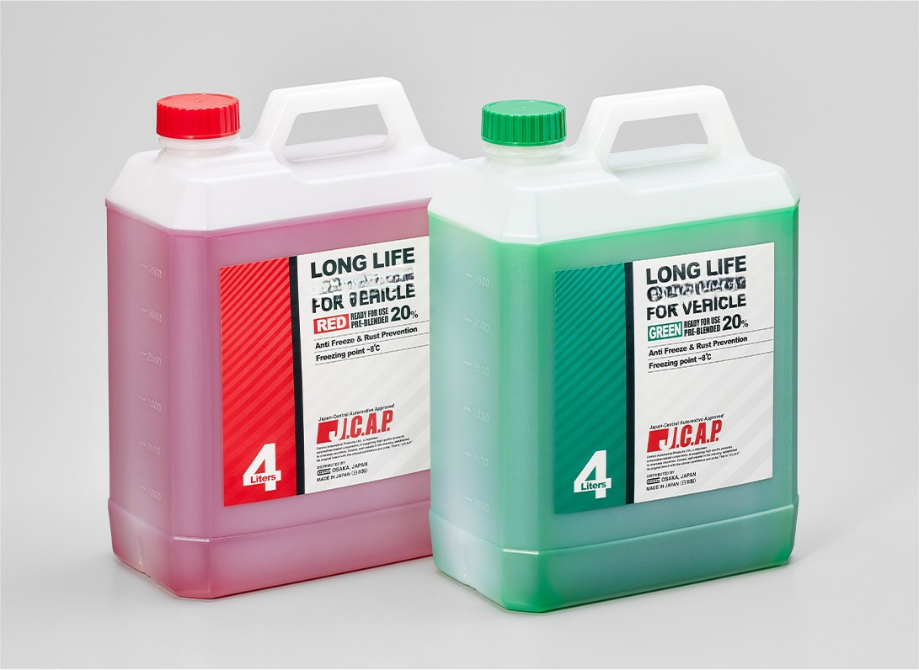

A. Windshield washer fluid

B. Antifreeze (Coolant)

C. Transmission fluid

D. Brake fluid

**Correct Answer: B. Antifreeze (Coolant)**

1. This type of oil, once used and dirty, is considered hazardous waste. What is it?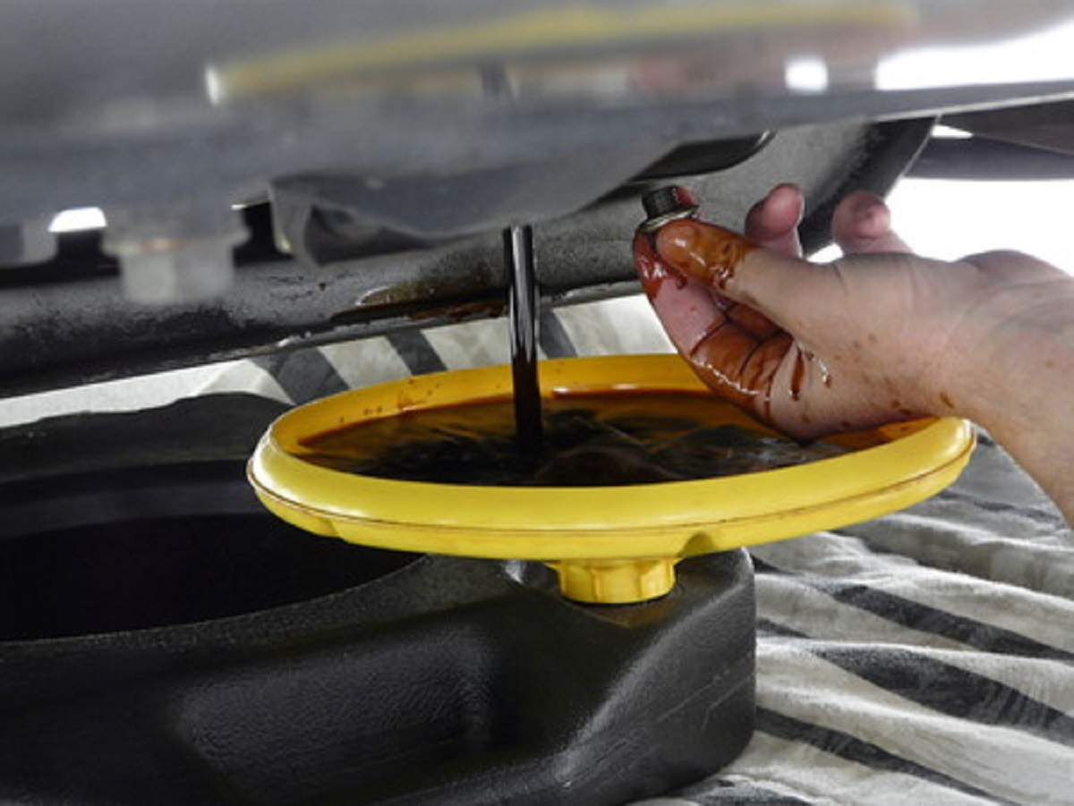

A. Synthetic oil

B. Crude oil

C. Transmission oil

D. Used motor oil

**Correct Answer: D. Used motor oil**